Content Amplification WORKBOOK

Interactive Workbook

Use the following pages to assist in evaluation and creation of your content amplification strategy. You will use what you learned in this workshop to complete this quick start guide.
There are five main interactive sections of this worksheet:

1: Amplification Goals & KPI’s

2: Content Audit

3: Content Ideation

4: Promotion Channel Selection

5: User Journey

Best to start with the end in mind.
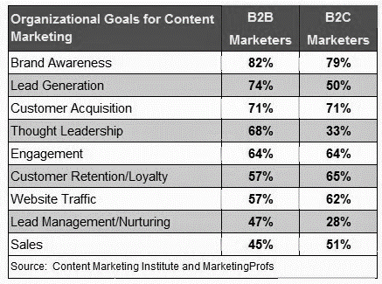
As content strategy and amplification strategy work together to achieve overall company goals, it is ideal to establish what you are looking to accomplish before beginning analysis and construction of a strategy.

Amplification Goals
Write down the most important marketing goals for your company. Goals should have metrics. What will you measure? How will you know you're successful?
- Brand awareness
- Educating your audience
- Moving leads through the sales funnel
“We need to stop interrupting what people are interested in and be what people are interested in.” ~ Craig Davis, former Chief Creative Officer at J. Walter Thompson.
- Audience engagement
- Client retention
10 Content Marketing Goals Worth Pursuing - Sonia Simone >> Read More
- New client leads
- Establishing authority in your niche
- Solving problems for your audience

1. Amplification Goals - Fill in your high-level goals and corresponding KPI’s – what do you wish to achieve through promotion and how will you know if it’s working?

1a. Goals
1 | Ex: Brand Awareness
2 | Ex: Drive Calls
3
4
5

1b. Measurement KPI’s
1 | Ex: Brand Awareness | Ex: Unique Sessions
2 | Ex: Drive Calls | Ex: Calls
3
4
5

Tip
Collaborate with your team to tweak these and get buy-in. Set up systems to measure and track results. Measuring is critical as it validates your strategy and tactics and enables the possibility for ROI calculations.
Learn More About Setting Up Tracking
Check out this resource to learn more about goal setting and determining what metrics you should be tracking for your website.
- Setting up Google Analytics – The complete checklist of resources for setting up your website tracking correctly.

Analytics - What am I looking for?
Setting up analytics can be tricky but knowing what to look for to make strategic decisions can be even more challenging. Start with the following areas in Google Analytics to get an idea of traffic source, traffic quality, and path to conversion (Note: the following instructions apply to Analytics properties that have data and conversion goals to play with)

Where is my current traffic coming from? 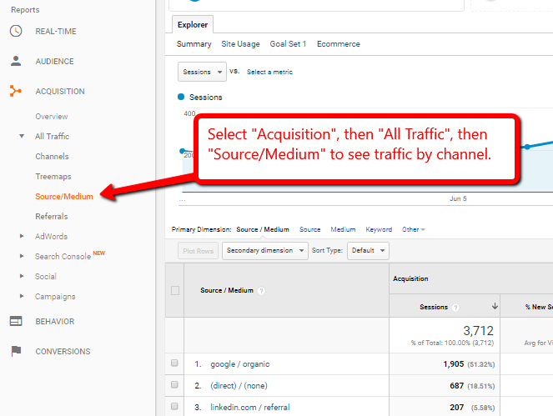

Is that traffic engaging with my content?
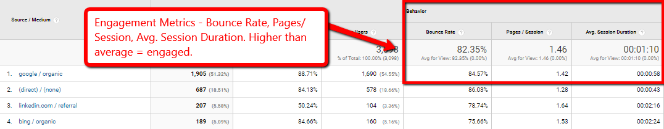

How are channels contributing to overall goals?
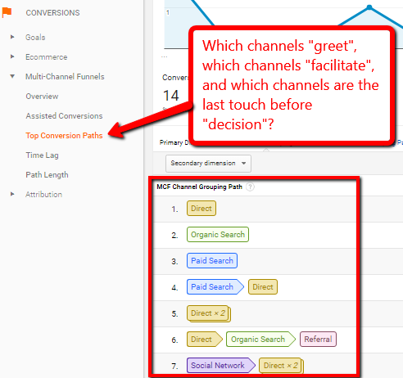

Examples: Amplification metrics that matter

Improve Paid Traffic | Avg. position, CTR, Quality Scores, Avg. CPC, ROI
Educate Audience | Avg. time on page, pages per session, return visitors, brand mention lift
Drive qualified leads | Conversion rate (CVR), Cost-per-lead (CPL), Cost-per Customer Acquisition (CPA)
Encourage social sharing | Social shares, comments, mentions, likes, click-throughs
Start/own the conversation | Comments, external links, shares, email forwards
Personalize brand | N/A - Conduct qualitative research following content campaigns
Increase brand following | Direct traffic, Email subscription growth, unique open rate, unique CTR, brand mentions, external links

The Funnel – The Why, What, & When.
Your customers follow predictable patterns in the decision-making process. As a best practice, you should have the stages mapped out from the earliest point of your relationship - they've never heard of you - all the way through to decision and potential advocacy. Each piece of content that you promote will reach your prospects in a specific stage of the funnel. That piece of content should help move them through to the next step or even help them skip a step to move them further down the funnel.
There are many ways to describe each step. Here is a sample funnel process detailing audience stage, intent, and the potential role content plays at each level of the funnel:
Stage | Audience Goal | Content Role
Awareness | Need/Want Recognition | Ex: Create emotional reaction
Consideration | Research | Ex: Answer frequent questions
Decision | Action | Ex: Promote urgency, provide validation
Advocacy | Feedback/Return | Ex: Encourage feedback, recurring promotions

Tip
This user journey is generic. Take the time to evaluate your customer's buying process utilizing the Analytics insights above to make sure you understand all the steps. Remember, each piece of content and amplification effort should focus on a stage of the buying process and should meet their focused interest to move them further down the funnel. Are you promoting content that is useful and helpful?
Another way to outline the buying process is to make a list of the questions your customers typically ask prior to purchase. You will find that these are common questions from prospective customers. Prioritize this list from top of the funnel to purchase.
Consider the types of candidates and prospects as well. Are they different based on location, age, income level, and/or other factors?

Learn More
- Understanding the Buying Process – E-Book
- 5 Stages of Consumer Buying Decision Process – Blog Post

2. Content Audit – What to promote?
It's important to understand what content is on your site to see the depth and breadth of our current content footprint – time for a content audit.
This audit will help you evaluate where you are strong and where content gaps exist. You'll find great pages and you'll find pages that need refreshing. List out some pages of content on your site using the form below…we're sure you'll see areas for opportunity.

Content Audit
Title | Stage | Format | Publication | Notes
Ex: How to… | Consideration | Article | 6.10.14 | Out of date, could use video…

Tip – Only promote your highest engaging content – Find the 10%!
- Download Screaming Frog to crawl your site. This software will give you a report of all your pages and posts in a spreadsheet format. This will save you time and give you a complete list without any manual action. Add columns to the spreadsheet to help organize what content you will keep, what content needs refreshing and what content is outdated and needs to be deleted.
- Review your content in Google Webmaster Tools – also known as Search Console - to determine the most popular content, highest converting pages, pages with the longest user engagement and the content where users tend to leave your site the most. This review will help you identify what content is resonating with your audience and what content needs to be improved.

3. Content Creation (Ideation)
Following your assessment if you found content lacking you may need to build before you can promote – try these questions on for size.

Tips:
- Stay Organized! Sample: Content Editorial Calendar Template – EXCEL spreadsheet content calendar.
- 105 Ideas to fill up your content calendar. Jay Baer - Convince and Convert
Name 5 experts in your industry or community that you could interview for either a blog post or video interview or other content piece.
__________________ | __________________ | __________________ | __________________ | __________________

What free guides, case studies or e-books could you develop in the next 90 days?
__________________ | __________________ | __________________ | __________________ | __________________

What presentations have you given recently that you could re-purpose?
__________________ | __________________ | __________________ | __________________ | __________________

What customers can you interview for either a blog post or video interview?
__________________ | __________________ | __________________ | __________________ | __________________

What webinars or podcasts could you create in the next 6 months?
__________________ | __________________ | __________________ | __________________ | __________________

Name major events, conference or holidays you could create content around.
__________________ | __________________ | __________________ | __________________ | __________________

4. Content Promotion – aka Amplification
Think about where you will promote your content. Many of us have a blog on our site so that makes a natural publishing channel. There are also many other places you can distribute your content.

Amplify – Promoting your content to your audience
Check off the channels where you can distribute your content. Then circle the channels you have the budget to promote on. Pick the channel most aligned with your audience to increase the value of your promotion.
Current Distribution Channels | Social Media Channels
❑ My Blog | ❑ Facebook
❑ Corporate website | ❑ Google+
❑ Industry related site | ❑ LinkedIn
❑ Association site | ❑ Pinterest
❑ Guest Post | ❑ Twitter
❑ E-mail | ❑ Instagram

Paid Media
❑ Paid Search | ❑ Twitter
❑ Programmatic | ❑ LinkedIn
❑ Influencer | ❑ Pinterest
❑ Facebook | ❑ Instagram

5. User Journey: Fill in the steps to your own sales funnel.
 | Ex: Audience | Ex: Channel | Ex: Content Role | Funnel #1  (Audience) | Funnel #1  (Channel) | Funnel #1  (Content Role)
Stage 1 | Prospect has identified an issue, challenge, or problem they need to resolve | Sponsored Social | Creates emotional connection, ex: Rich media
Stage 2 | Prospect starts researching by asking questions and looking for solutions | Paid Search | Directly answers frequent questions, ex: Lists
Stage 3 | Prospect identifies different solutions and available remedies | Lead nurture | Evaluation instructions, ex: E-book
Stage 4 | Prospect identifies specific criteria to make a decision | Video retargeting | Validation of decision, ex: Video of recent purchaser’s journey and feedback
Stage 5 | Prospect has evaluated different solutions and criteria, and decides on a vendor | Lead Nurture | Solicitation of feedback, ex: Purchase survey or review request

Conclusion: Now what?
Use these resources to construct an amplification plan with the understanding that in most cases it is necessary to utilize multiple channels and multiple types of content to effectively use promotion to grow audience size and increase engagement throughout your sales cycle.

Last Tip
Not addressing a gap in content or promotion may lead you to building awareness, or assisting with consideration, only to have another brand pick up your audience down the road. Don’t cut corners!

